## Open Micro:bit MakeCode

* Navigate to https://app.edublocks.org/editor in your browser.
* Click New Project with name “DisplayNameBadge”.

## Exercise 1 – Display Name Badge

Write a program to display your name

## Connect Micro:bit to computer

1. Connect Micro:bit to computer
2. Download program to Micro:bit

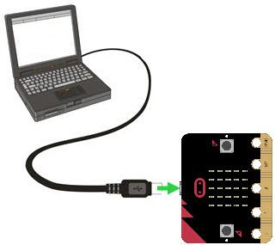 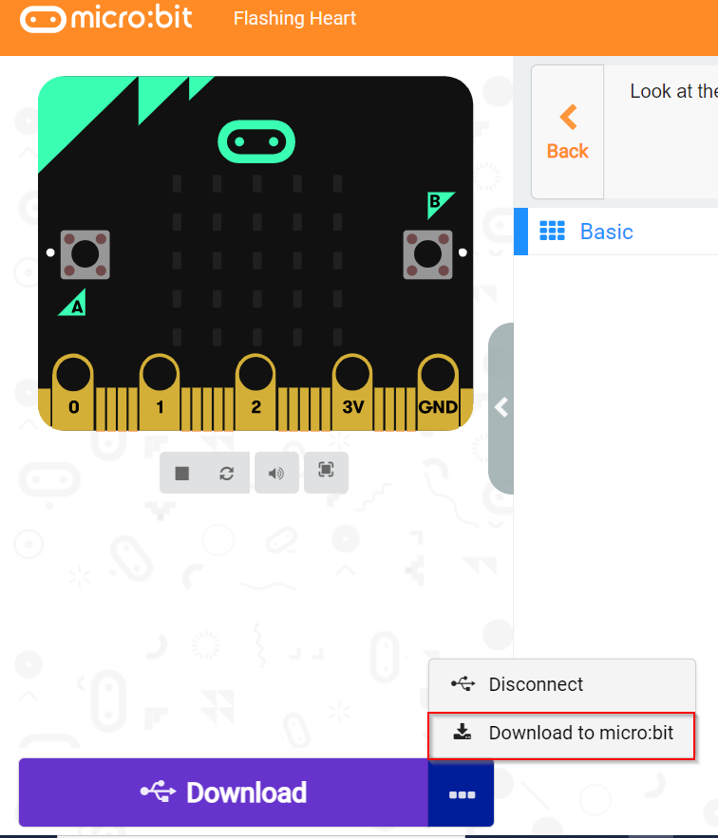

## Exercise 2 – Display Heart beat

*Hint: Use show icon small and big heart in Display library.*

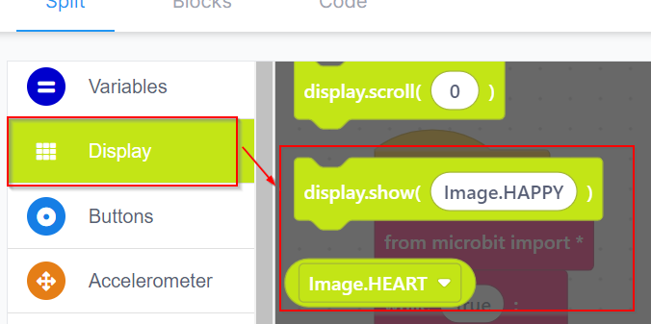

Loop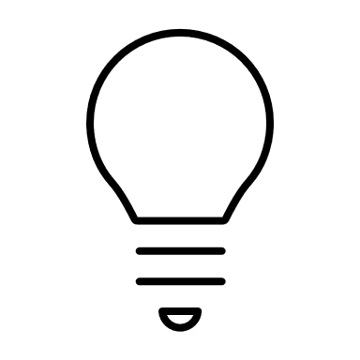

**Loop** is a sequence of instructions that is continually repeated until a certain condition is reached.

## Exercise 3 – Count Down Timer

Write a program to countdown time from 0 to 10 or 10 to 0.

*Hint: Use* ***for block*** *in Loops section and* ***show number*** *in Basic library.*

## Exercise 4 – Show Emoticons

Write a program to show happy face when button A is pressed and sad face when button B is pressed.

*Hint: Use* ***on button pressed*** *in Input library and* ***show leds (Draw smiley)*** *in Basic library.*

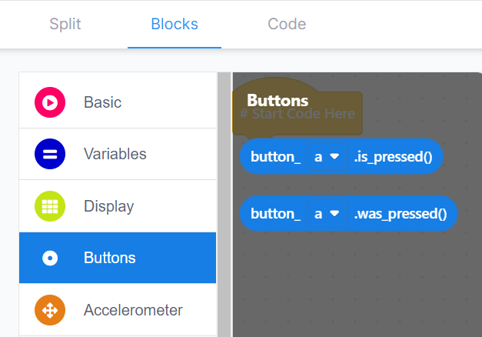 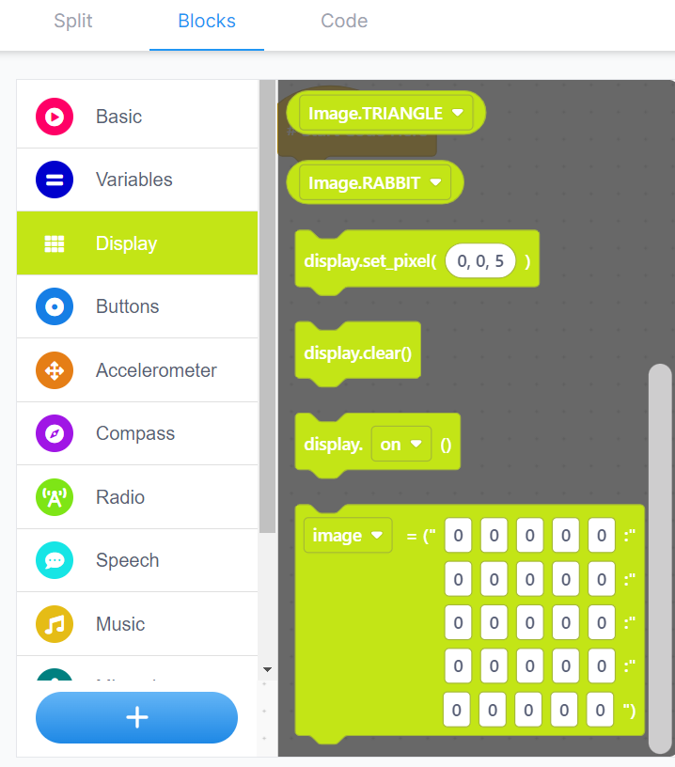

If Else conditional

**If, Else If– If Else**is a conditional statements, executed only the conditions are met.

## Exercise 5 – Shop Open/Closed Sign

Write a program to show Open/Closed sign.

When Button A is pressed OPEN

When Button B is pressed CLOSED

(Add Else to NONE and see what happens and why it is shown in the start.)

Hint: Use if else condition block

## Exercise 6 – Room Thermometer

Write a program to show room temperature when button A is pressed.

